The user API for predicting the destination neighborhood of riders takes in the information of the rider, current weather conditions and time, and plots on a New York City map the starting neighborhood of the rider, and the predicted end neighborhood. To use the API, one adjusts the widgets/sliding bars along the features that you would need to enter to enter in the data that the underlying machine learning model will predict upon. The user interface takes in the input data given by the user (given by dragging the sliding bars and selecting from dropdown options within the interface), converts it into the numpy array format which the machine learning model uses to predict destination neighborhood, and then outputs the destination neighborhood shaded on the New York City map in Red. The predicted trip information is then printed on the bottom of the map.

The application as mentioned above, takes in user inputs through the form of sliding bars for numeric values, and dropdown menus for categorical values. (See below). The information required for the model to train are (start station, user type, birth year, gender, time of day, humidity, temperature, weather description, wind speed, and day of week. These are all conditions that are determined at the time of taking the bike out that should be easily observable by the rider. 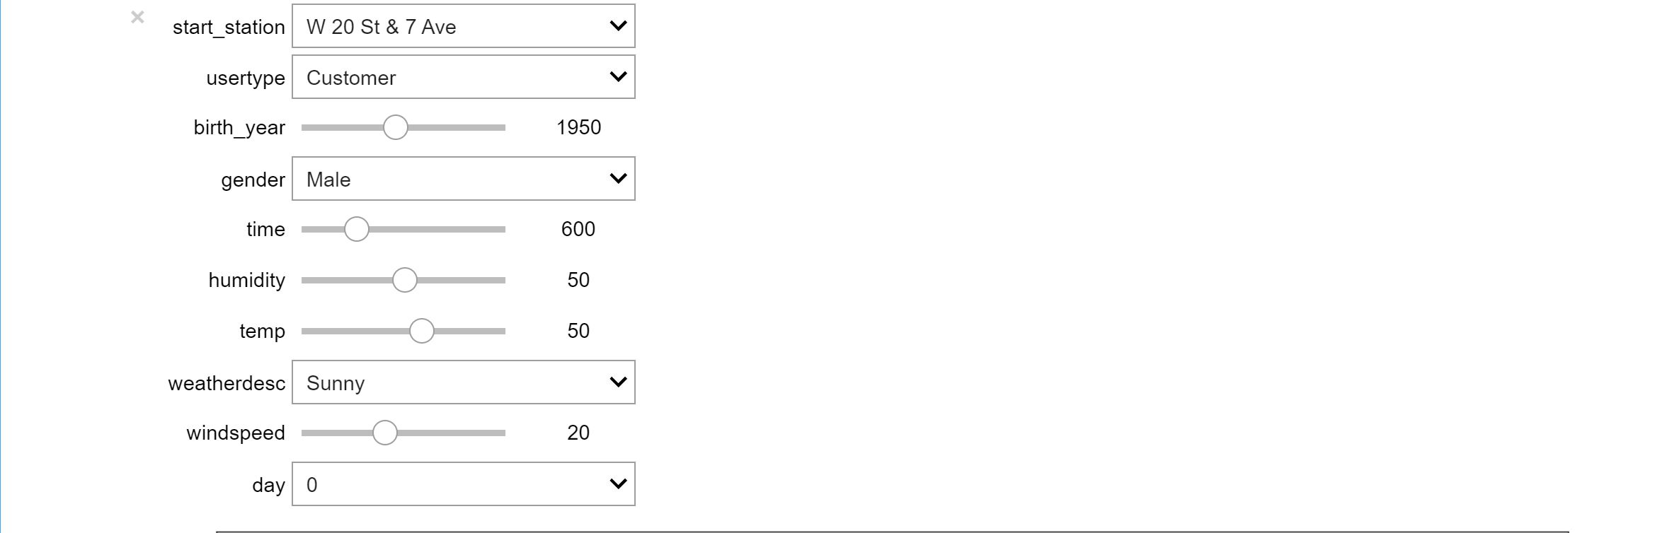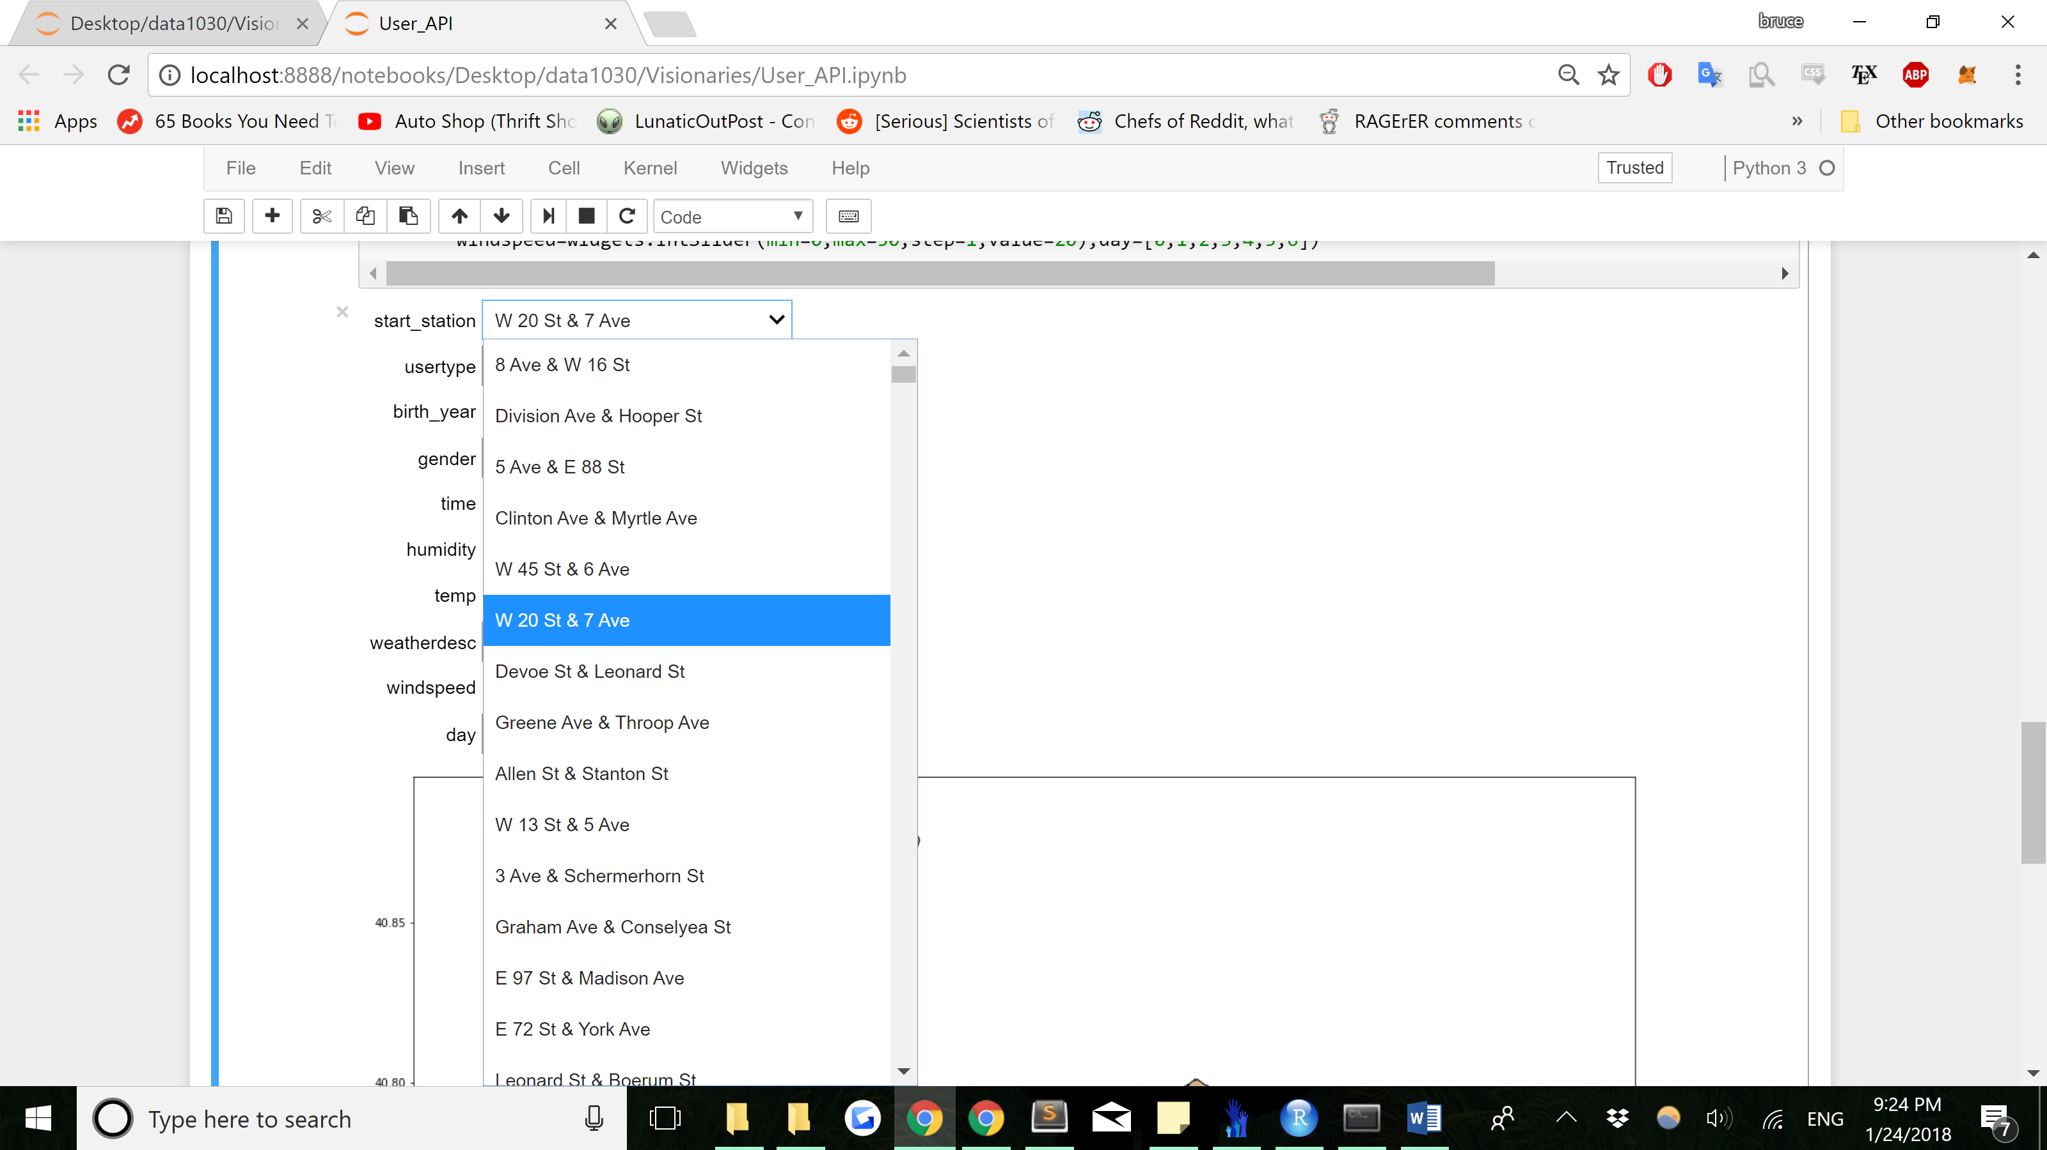

Once the values are entered and picked as above, a map is output, with the trip information. (See Below). The trip information will be displayed on the bottom of the map.

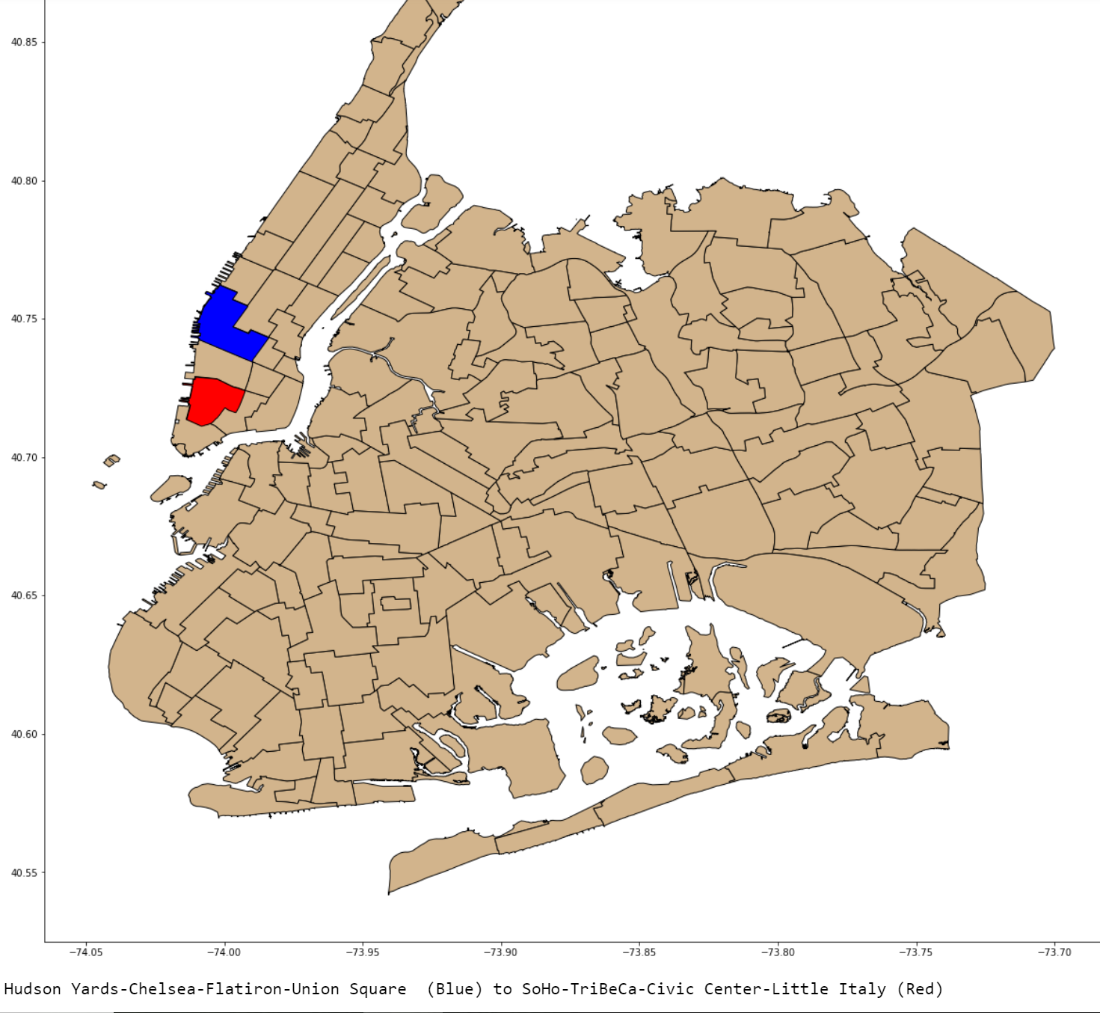

Queens is also included in the predictions!(See Below). This is an example of a Morning Commute.

